CS 213: Artificial Intelligence Laboratory

# Lab 5 Report: Desdemona

## Tejal Ladage 210010026

## Ashwin Waghmare 210010060

**Introduction**

The objective of this task is to code a Bot to play the game of Othello in an optimal way, in order to win the game. With a given a board configuration and a turn, your bot will return a valid move. The game ends when neither of the players can make a valid move. The player with the maximum number of coins is the winner.

**Description of Algorithms**

**Minimax Algorithm**

Minimax is a decision rule used in decision theory, game theory, statistics, and philosophy for minimizing the possible loss for a worst case (maximum loss) scenario. This algorithm makes a tree of positions as it explores all possible moves by the opponent. When it reaches the required depth, it assesses the position using a heuristic/evaluation function. It evaluates the best move such that it minimizes the best move of the opponent in the course of game.

**Alpha Beta Pruning**

Alpha-Beta Pruning seeks to minimize the number of positions explored in the search tree by the Minimax algorithm. It stops evaluating a move when at least one possibility has been found that proves the move to be worse than a previously examined move. So, such moves need not be evaluated further and hence it prunes the search tree such that the outcome of the algorithm remains unchanged in the algorithm.

**Heuristic Functions**

**Corner Edge Captivity**

Capturing stable positions of the board significantly increases the chance of winning. The heuristic value of the positions are calculated through Machine Learning algorithms.

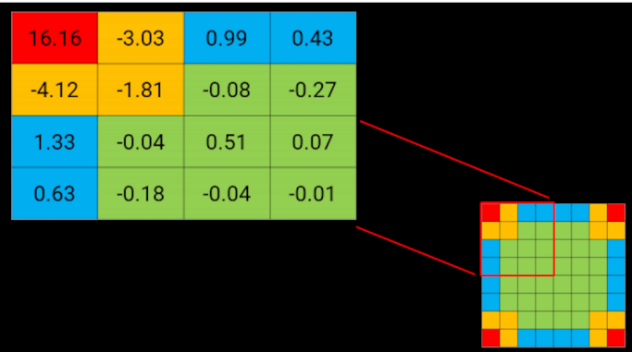

**Coin Parity**

This heuristic functions returns the lead of our bot with respect to other bot. That is the difference between our number of coins and opponent’s number of coins.

**Possible Moves**

This heuristic function returns the difference of our possible moves and opponent’s possible moves.

**Game tree for Alpha Beta Pruning**

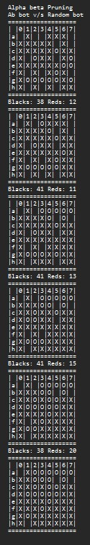 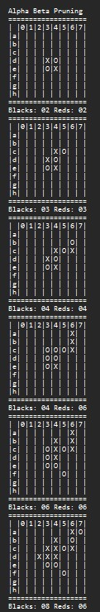 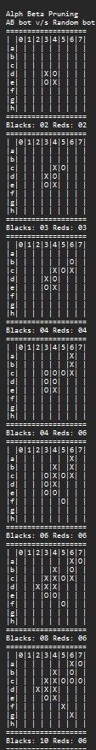

**Game Tree for Minimax Algorithm**

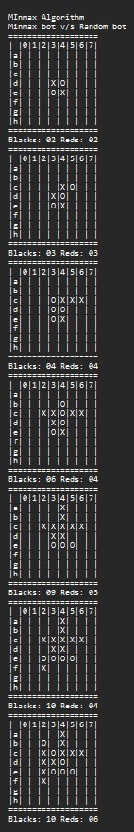 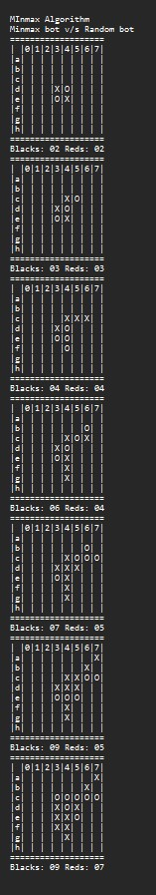 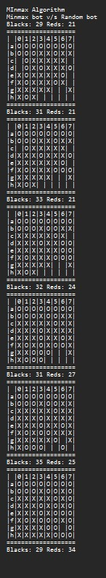

**Comparison between Algoithms**

**Space and Time complexity**

The Alpha-Beta Pruning Algorithm has lesser time and space complexity as it moves that are guaranteed to be worse than previously examined moves, are not further explored. Thus by eliminating worse states that need not be explored, the space complexity is reduced. Since, lesser states are explored, in comparison to Minimax, the time complexity is also lesser in case of Alpha-Beta Pruning Algorithm.

**Winning Criteria**

Alpha Beta bot has the advantage of exploring greater depths compared to the Minimax Bot, due to the time constraint per move of 2 seconds. When this is relaxed, both the bots are ideally expected to play equally well. Multiple trials show that the two bots play nearly equally well and that there is a general trend of the winning bot being the one that starts the game first. This is the effect of heuristics over the winning chances of the bot.